Project Design Phase-II
Technology Stack (Architecture & Stack)

Date | 01 July 2026
Team ID
Project Name | DarshanEase – Temple Darshan Booking System
Maximum Marks | 4 Marks

Technical Architecture:
The Deliverable shall include the architectural diagram as below and the information as per the table1 & table 2
Example: DarshanEase – Temple Darshan Booking System
Reference: https://developer.ibm.com/patterns/ai-powered-backend-system-for-order-processing-during-pandemics/
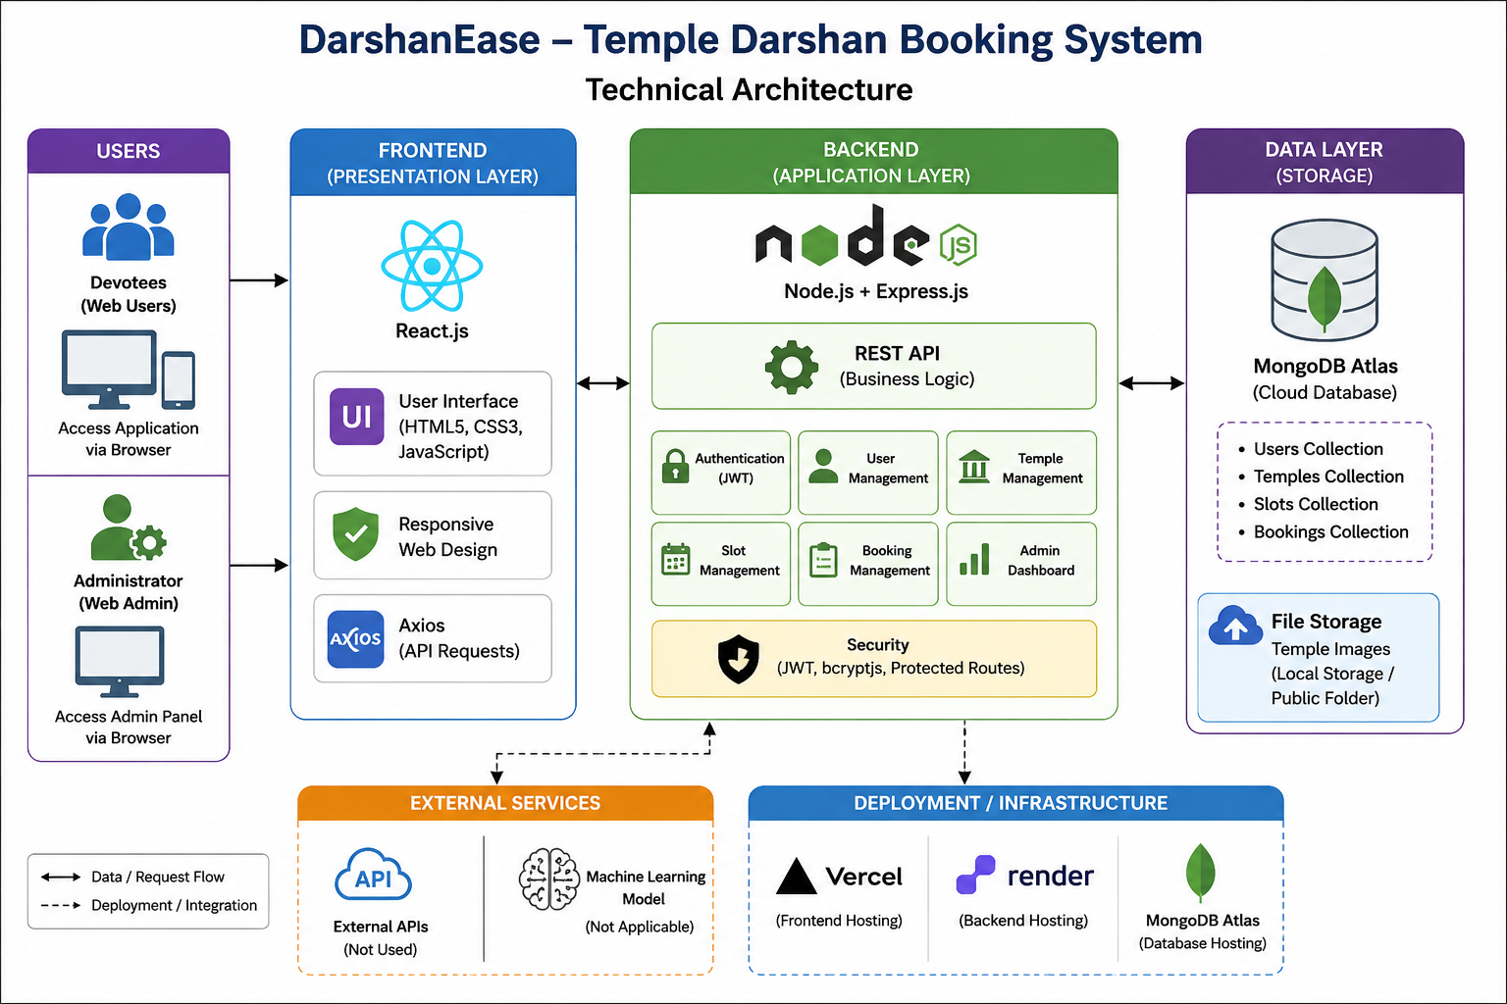

Table-1 : Components & Technologies:
S.No | Component | Description | Technology
 | User Interface | Web application for users and administrators | React.js, HTML5, CSS3, JavaScript
 | Application Logic-1 | User Authentication and Authorization | Node.js, Express.js, JWT, bcryptjs
 | Application Logic-2 | Temple, Slot and Booking Management APIs | Express.js, REST API
 | Application Logic-3 | Database Operations | Mongoose ODM
 | Database | Stores Users, Temples, Slots and Bookings | MongoDB
 | Cloud Database | Cloud Database Service | MongoDB Atlas
 | File Storage | Temple Images | Local Storage / Public Folder
 | External API-1 | No external API used | N/A
 | External API-2 | No external API used | N/A
 | Machine Learning Model | Not Applicable | N/A
 | Infrastructure (Server / Cloud) | Frontend deployed on Vercel, Backend deployed on Render | Vercel , Render

Table-2: Application Characteristics:
S.No | Characteristics | Description | Technology
 | Open-Source Frameworks | React.js, Node.js, Express.js, MongoDB, Mongoose, Axios | Open Source Framework
 | Security Implementations | JWT Authentication, Password Encryption using bcryptjs, Protected Routes | JWT , bcryptjs
 | Scalable Architecture | Three-Tier MERN Architecture supporting future expansion | React.js, Express.js, MongoDB Atlas
 | Availability | 24×7 Cloud Deployment using Vercel, Render and MongoDB Atlas | Vercel, Render
 | Performance | Fast REST APIs, Optimized MongoDB Queries, Lightweight React UI | Express.js, MongoDB Atlas

References:
https://c4model.com/
https://developer.ibm.com/patterns/online-order-processing-system-during-pandemic/
https://www.ibm.com/cloud/architecture
https://aws.amazon.com/architecture
https://medium.com/the-internal-startup/how-to-draw-useful-technical-architecture-diagrams-2d20c9fda90d

